Data Communications
AND Networking
Chapter 4





REVISION 1

-------------------------------------------------
CREDITS
RAS@DefinitelynotRas
prosenjit@prosenjit_mondol
Some explanations are highlighted like this text,
Which are not part of math, actually!

Chapter 4 | Quizzes

List three techniques of digital-to-digital conversion.
The three different techniques described in this chapter are
- Line coding
- Block coding, and
- Scrambling.

Distinguish between a signal element and a data element.
A data element is the smallest entity that can represent a piece of information (a bit). A signal element is the shortest unit of a digital signal. Data elements are what we need to send; signal elements are what we can send. Data elements are being carried; signal elements are the carriers.

Distinguish between data rate and signal rate.
The data rate defines the number of data elements (bits) sent in 1s. The unit is bits per second (bps). The signal rate is the number of signal elements sent in 1s. The unit is the baud.

Define baseline wandering and its effect on digital transmission.
In decoding a digital signal, the incoming signal power is evaluated against the baseline (a running average of the received signal power). A long string of 0s or 1s can cause baseline wandering (a drift in the baseline) and make it difficult for the receiver to decode correctly.
Q4-5. Define a DC component and its effect on digital transmission.
Answer: When the voltage level in a digital signal is constant for a while, the spectrum cre ates very low frequencies, called DC components, that present problems for a sys tem that cannot pass low frequencies.
Q4-6. Define the characteristics of a self-synchronizing signal.
Answer: A self-synchronizing digital signal includes timing information in the data being transmitted. This can be achieved if there are transitions in the signal that alert the receiver to the beginning, middle, or end of the pulse.
Q4-7. List five line coding schemes discussed in this book.
Answer: In this chapter, we introduced unipolar, polar, bipolar, multilevel, and multitran sition coding.
Q4-8. Define block coding and give its purpose.
Answer: Block coding provides redundancy to ensure synchronization and to provide inher ent error detecting. In general, block coding changes a block of m bits into a block of n bits, where n is larger than m.
Q4-9. Define scrambling and give its purpose.
Answer: Scrambling, as discussed in this chapter, is a technique that substitutes long zero level pulses with a combination of other levels without increasing the number of bits

Q4-10. Compare and contrast PCM and DM.
Answer: Both PCM and DM use sampling to convert an analog signal to a digital signal. PCM finds the value of the signal amplitude for each sample; DM finds the change between two consecutive samples.
Q4-11. What are the differences between parallel and serial transmission?
Answer: In parallel transmission we send data several bits at a time. In serial transmission we send data one bit at a time.
Q4-12. List three different techniques in serial transmission and explain the differences.
Answer: We mentioned synchronous, asynchronous, and isochronous. In both synchro nous and asynchronous transmissions, a bit stream is divided into independent frames. In synchronous transmission, the bytes inside each frame are synchro nized; in asynchronous transmission, the bytes inside each frame are also indepen dent. In isochronous transmission, there is no independency at all. All bits in the whole stream must be synchronized.

Chapter 5 | Problems

Calculate the baud rate for the given bit rate and type of modulation.
We use the formula , but first we need to calculate the value of r for each case with
a. 2000 bps, FSK
In FSK, each symbol represents one bit, r=1
S= N(1/r)
Thus, the baud rate is equal to the bit rate.
Baud rate = Bit rate
For 2000 bps, FSK: Baud rate = 2000 baud.
b. 4000 bps, ASK
In standard ASK (Binary ASK), each symbol represents one bit, r=1
S=N
For 4000 bps, ASK: Baud rate = 4000 baud.
c. 6000 bps, QPSK
In QPSK, each symbol represents 2 bits, r=2
S= N (1/2)
For 6000 bps, QPSK: Baud rate = 6000 / 2 = 3000 baud.
d. 36,000 bps, 64-QAM
In 64-QAM, each symbol represents 6 bits (since 64 = 2^6), r=6
S= N (1/6)
For 36,000 bps, 64-QAM: Baud rate = 36,000 / 6 = 6000 baud.

Calculate the bit rate for the given baud rate and type of modulation.
We use the formula or, , but first we need to calculate the value of r for each case with
a. 1000 baud, FSK
In FSK, each symbol represents one bit, r=1
N= S*r= 1000*1= 1000
For 1000 baud, FSK: Bit rate = 1000 bps.
b. 1000 baud, ASK
In binary ASK (similar to binary FSK), each symbol represents one bit, r=1
N= S*r= 1000*1= 1000
For 1000 baud, ASK: Bit rate = 1000 bps.
c. 1000 baud, BPSK
In BPSK, each symbol represents one bit, r=1
N= S*r= 1000*1= 1000
For 1000 baud, BPSK: Bit rate = 1000 bps.
d. 1000 baud, 16-QAM
In 16-QAM, each symbol represents 4 bits (since 16 = 2^4), r=4
N= S*r= 1000*4= 4000
For 1000 baud, 16-QAM: Bit rate = 1000 × 4 = 4000 bps.

What is the number of bits per baud for the following techniques?
We use the following formula to calculate the value of r for each case with
a. ASK with four different amplitudes
With four different amplitudes, there are 4 possible signal states.
Bits per baud=log2​(number of amplitudes) =log2​(4) =2 bits per baud
b. FSK with eight different frequencies
With eight different frequencies, there are 8 possible signal states.
Bits per baud=log2​(number of frequencies) =log2​(8) =3 bits per baud
c. PSK with four different phases
With eight different frequencies, there are 4 possible signal states.
Bits per baud=log2​(number of frequencies) =log2​(4) =2 bits per baud
e. QAM with a constellation of 128 points
With 128 points in the constellation, there are 128 possible signal states.
Bits per baud=log2 (number of constellation points) =log2​(128) =7 bits per baud

Draw the constellation diagram for the following:
a. ASK, with peak amplitude values of 1 and 3
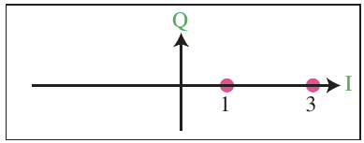
b. BPSK, with a peak amplitude value of 2
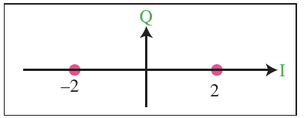
c. QPSK, with a peak amplitude value of 3
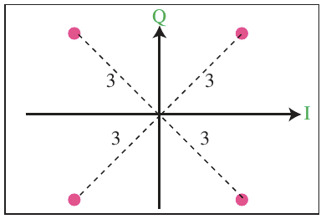
d. 8-QAM with two different peak amplitude values, 1 and 3, and four different phases
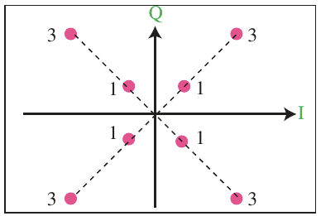

Draw the constellation diagram for the following cases. Find the peak amplitude value for each case and define the type of modulation (ASK, FSK, PSK, or QAM).The numbers in parentheses define the values of I and Q respectively.
a. Two points at (2, 0) and (3, 0)
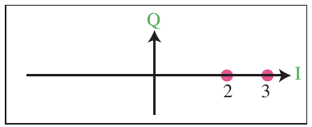
This is ASK. Cause there are two different amplitude with same phase 0. Here peak amplitudes are A1 = 2 and A2 = 3 respectively.
b. Two points at (3, 0) and (−3, 0)
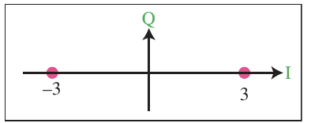
This is BPSK. Here peak amplitudes of the two are same but the phase is different. And it its 180 degree apart.
c. Four points at (2, 2), (−2, 2), (−2, −2), and (2, −2)
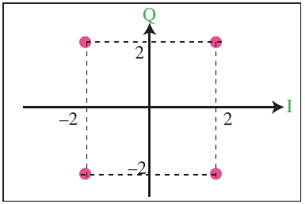
This can be either QPSK (one amplitude, two different phases) or, 4-QAM (one amplitude, two different phases).
QPSK is preferred. Check previous question!

d. Two points at (0, 2) and (0, −2)
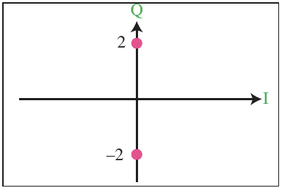
This is BPSK. Here peak are same but the phases are different.

How many bits per baud can we send in each of the following cases if the signal constellation has one of the following number of points?
The number of points define the number of levels, L. The number of bits per baud is the value of r. Therefore, we use the formula r = log₂L for each case.
a. Bits per baud=log2​(2)=1bit per baud
b. Bits per baud=log2​(4)=2bits per baud
c. Bits per baud=log2​(16)=4bits per baud
d. Bits per baud=log2​(1024)=10bits per baud

What is the required bandwidth for the following cases if we need to send 4000 bps? Let d = 1.
We use the formula B = (1 + d) x ()x N
but first we need the value of r for each case.
a. ASK
r = 1, B = ( 1 + 1 ) x ( 1 / 1) x 4000 bps = 8000 Hz
b. FSK with 2Δf = 4 KHz
r = 1, B = ( 1 + 1 ) x ( 1 / 1) x 4000 bps + 4000 = 12000 Hz
c. QPSK
r = 2, B = ( 1 + 1 ) x ( 1 / 2) x 4000 bps = 4000 Hz
d. 16-QAM
r = 4, B = ( 1 + 1 ) x ( 1 / 4) x 4000 bps = 2000 Hz

P5-8. The telephone line has 4 KHz bandwidth. What is the maximum number of bits we can send using each of the following techniques? Let d = 0
We use the formula
But first we need the value of r for each case.
a. ASK
r = log₂2=1, N = [1/(1+0)]x1x4 kHz = 4 kbps
b. QPSK
r = log₂4=2, N = [1/(1+0)]x2x4 kHz = 8 kbps
c. 16- QAM
r = log₂16=4, N = [1/(1+0)]x4x4 kHz = 16 kbps
d.64-QAM
r = log₂64=6, N = [1/(1+0)]x6x4 kHz = 24 kbps

A corporation has a medium with a 1-MHz bandwidth (lowpass). The corpo ration needs to create 10 separate independent channels each capable of send ing at least 10 Mbps. The company has decided to use QAM technology. What is the minimum number of bits per baud for each channel? What is the number of points in the constellation diagram for each channel? Let d = 0.
First, we calculate the bandwidth for each channel = (1 MHz) / 10 = 100 KHz. We then find the value of r for each channel:
B = (1 + d) × (1/r) × (N)
→ r = N / B
→ r = (1 Mbps/100 KHz) = 10
We can then calculate the number of levels: L = 2^{r} = 2¹⁰ = 1024. This means that that we need a 1024-QAM technique to achieve this data rate.

A cable company uses one of the cable TV channels (with a bandwidth of 6 MHz) to provide digital communication for each resident. What is the available data rate for each resident if the company uses a 64-QAM technique?
We use the formula
But first we need the value of r.
r = log₂64=6, N = [1/(1+0)]x6x6 MHz = 36 Mbps

Find the bandwidth for the following situations if we need to modulate a 5-KHz voice.
a.AM
B_{AM} = 2 × B = 2 × 5 = 10 KHz
b. FM(β = 5)
B_{FM} = 2 × (1 + β) × B = 2 × (1 + 5) × 5 = 60 kHz
c. PM(β = 1)
B_{PM} = 2 × (1 + β) × B = 2 × (1 + 1) × 5 = 20 KHz

Find the total number of channels in the corresponding band allocated by FCC.
We calculate the number of channels, not the number of coexisting stations.
a. AM
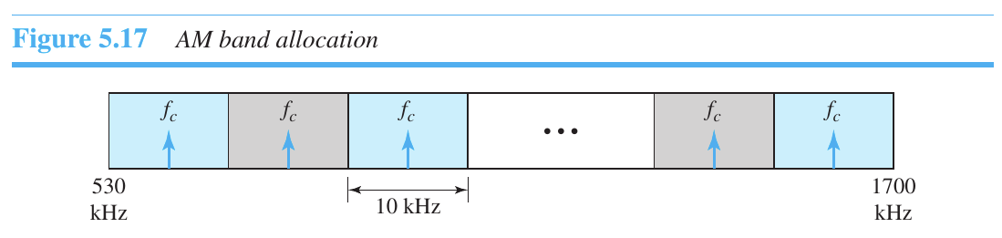
Number of channel, n = (1700 - 530) KHz / 10 KHz = 117
b. FM
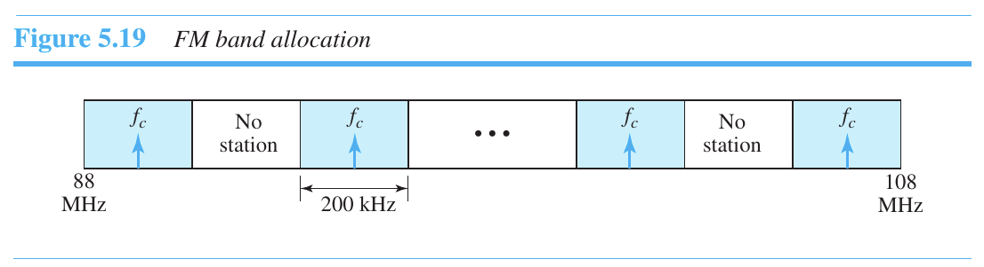
Number of channel, n = (108 - 88) MHz / 200 KHz =100

Wake up to reality! Nothing ever goes as planned in this accursed world. The longer you live, the more you realize that the only things that truly exist in this reality are merely pain, suffering and futility. ~Madara Uchiha

